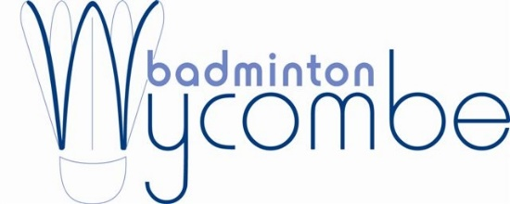

Amersham Satellite Badminton Club
Staffed by qualified, professional coaches

Terms and Conditions

- Full payment must be made at time of booking through our website.
- The term’s fees must be paid for in full unless otherwise stated.
- Unfortunately we are unable to refund payments for sessions cancelled by the customer.
- We reserve the right to amend or change instructor without prior notice. When cancellation is unavoidable alternative sessions or a pro rata refund will be offered.
- All bookings are dealt with on a first come first served basis.
- At time of booking, it is the individual/parent/carers responsibility to inform staff of any medical issues, which may affect the child’s participation.
- If for any reason the Club does not gain enough participants, Badminton Wycombe reserves the right to cancel the Club.

Badminton Wycombe
Wycombe Badminton Centre Ltd
Crest Road
High Wycombe
Bucks
HP11 1UA

Enquiries to : 01494 436 200

admin@badmintonwycombe.co.uk
www.badmintonwycombe.co.uk

